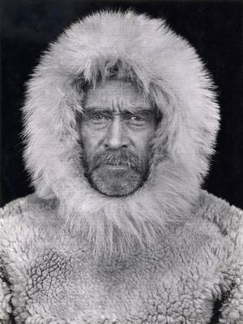
North Pole Explorers:
Robert Peary

Born: Robert Edwin Peary May 6, 1856
Cresson, Pennsylvania, U.S.
Died: February 20, 1920 (aged 63)
Washington, D.C., U.S.
Known for: Claim to have reached the geographic North Pole.

Robert Edwin Peary (May 6, 1856 – February 20, 1920) was an American explorer who claimed to have led the first expedition, on April 6, 1909, to reach the North Pole.

Peary tried several times to reach the North Pole before he succeeded. During one trip he lost several toes due to frostbite. In 1905–06 he used a powerful ice-breaking ship for the first part of his trip. This time Peary came closer to the Pole than anyone before him had come.

Peary tried again in 1908. He, Henson, and four Eskimo (Inuit) made the last stage of the trip on dogsleds. Peary and Henson both reached the North Pole on April 6, 1909. Some people believe that Henson reached the Pole before Peary.
Peary retired from the Navy in 1911. He died in Washington, D.C., on February 20, 1920.

