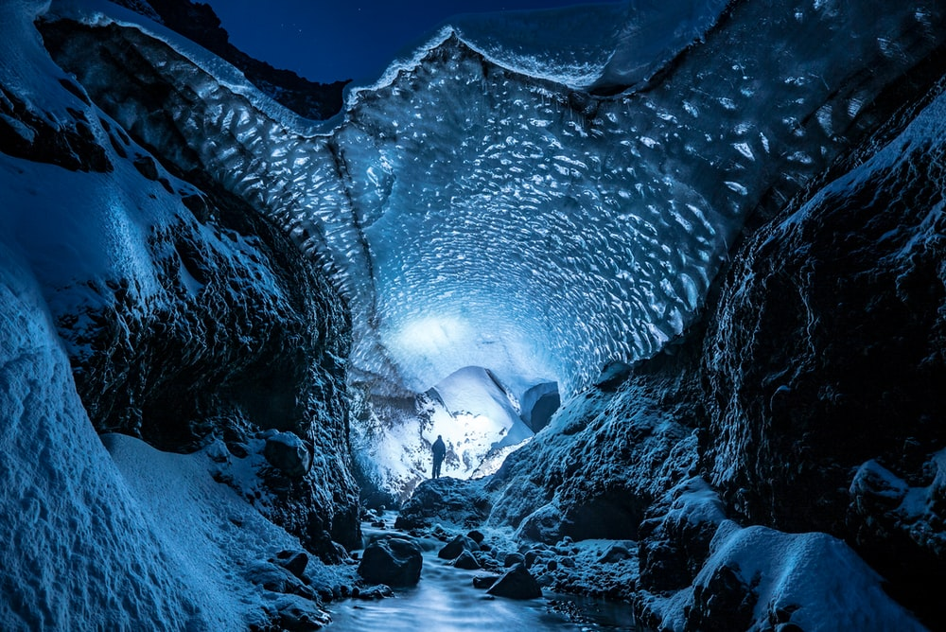

Bright powdery soft glowed still

Huge lit long, dark frozen

sharp

**Additional Support task: Snow Cave**

Fill in the missing words using the word bank:

1. The ceiling of the cave _______ and ____ up the entrance.
2. On the floor was ________ snow, which lay _____ and untouched.
3. _____ stone boulders lined the pathway.
4. Large, ________ icicles hung down, with _____ dangerous-looking tips.
5. There was a ______ light in the distance at the end of the ______ tunnel.