17th November 2017

Dear Parents

We will be holding our annual ‘Clubs Event’ on Friday 24th November at 2.30p.m.when we invite various clubs to come into school to showcase their organisation.

We would like to invite you along to see for yourselves the variety of clubs attending. They will be running demonstrations and will be available to talk with you and your child about their club. You will have the opportunity to sign up if you would like to.

If your child belongs to a club they are welcome to bring in their ‘uniform or kit’ on the Friday and join their club’s stand to chat to their fellow pupils about their experiences and the activities they could take part in as a member. They may also like to join you to have a look at other clubs that are available in our area.

May we confirm that as this event is taking place there will not be any Snuggle Buggle, Chrysalis Capers or Words with Wings on that Friday.

We look forward to seeing as many of you as possible on the day.

Yours sincerely

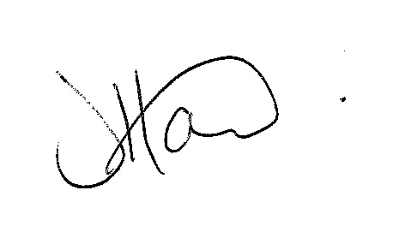

Ms J Howard
Headteacher

