19th September 2017

Dear Parents and Carers,

I would like to take this opportunity to invite you all into school on Friday 22nd September at 2pm.

We have exciting news to share with you about the changes we are making to Snuggle Buggle, Chrysalis Capers and Words with Wings, we will also be giving your child’s class teacher the opportunity to explain about the stimulating learning we have planned for the year ahead.

Please come along and find out more.

We will look forward to seeing you.

Yours sincerely
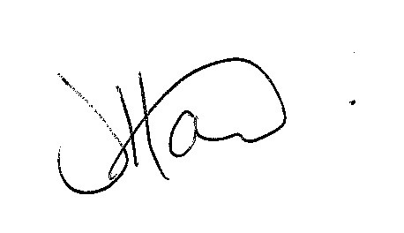
Ms J Howard

