20th December 2017

Dear Parents,

We would like to advise you that your child will have the opportunity to swim for 5 sessions at Rye Sports Centre this term.

Our school is committed to ensure that all children can swim by the time they leave primary education, therefore please support us in enabling your child to access the lessons, by ensuring they are in school with their swimming kit.

We continue to employ Lee Cornelius as our swimming teacher as we know what an excellent teacher he is, we are able to pay for Lee with use of the Sports Grant given to school, this helps us keep the cost that we pass to you as low as possible. In addition, this year we are also timetabling Mr Sayer to add value to these lessons and ensure the safety of our children in our local water-based environment.

As we made you aware in our swimming letters last year, our voluntary contributions from parents has gradually been reducing, while overall costs are increasing, leaving us to make some difficult financial decisions regarding our swimming commitment. We therefore urge you to pay as much as you can to ensure that swimming can continue. The voluntary contribution is £16.67 for the 5 sessions, which we would appreciate as a payment in the first week your child swims.

They will need to bring a swimming costume and towel, and the girls must wear their hair tied back.

Please pay via Schools Cash Office online, or if you are sending cash into school please ensure it’s in a named envelope to the school office.

Term 3 | Class | Time
Term 3 | Stingrays | 9.30 – 10.30
Term 3 | Killer Whales | 10.30 – 11.30

Yours sincerely
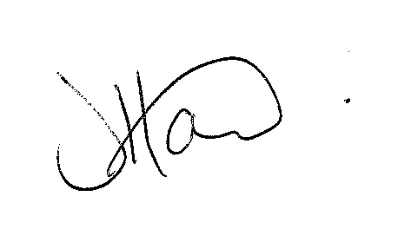
Ms J Howard
Headteacher

