16th October 2017

Dear Parents and Carers,

I am writing to you in light of some comments and opinions I have received in relation to this term’s attendance reward. As you are aware attendance is an important area that we need to focus on at Rye Primary and we are always looking at ways in which we can improve this. The decision to introduce a termly reward was not made lightly but we felt this would be a nice way to congratulate all our children achieving 100% attendance.

I realise this view has not been shared by all of our parents and quite a lot of input has been made on social media, this often escalates situations. I would prefer that any grievances be made to the school, as you know I am always here to listen to your thoughts and opinions and I take on board every one of them, please come and talk to me, I am on the door most mornings or you may call into the office to make an appointment to see me.

I would like to stress that the attendance reward will be a termly event and if your child hasn’t managed 100% this term then there are 5 more terms left this academic year and therefore plenty more chances to achieve 100%.

A number of parents have brought to my attention the need for hospital appointments for ongoing health conditions, I appreciate this is out of your control and I will not be including hospital appointments within the 100% however we will require a copy of the hospital appointment letter or appointment card.
Also a number of parents have stressed their concerns at sending their child in when they are ‘Not quite right’ or ‘Under the weather’, our advice would always be to send them to school, we will keep a close eye on them and we do have procedures we follow throughout school when it comes to children being sent home. We know your child and please can I assure you that we would call you if your child was unwell.
We would still like to stress that children need to be kept off school for 48hrs following a bout of sickness or diarrhoea.

Thank you as always for your continued support.

Yours sincerely

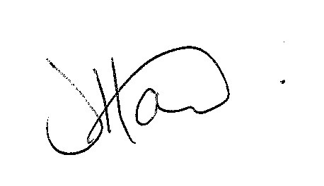

Ms J Howard
Headteacher

