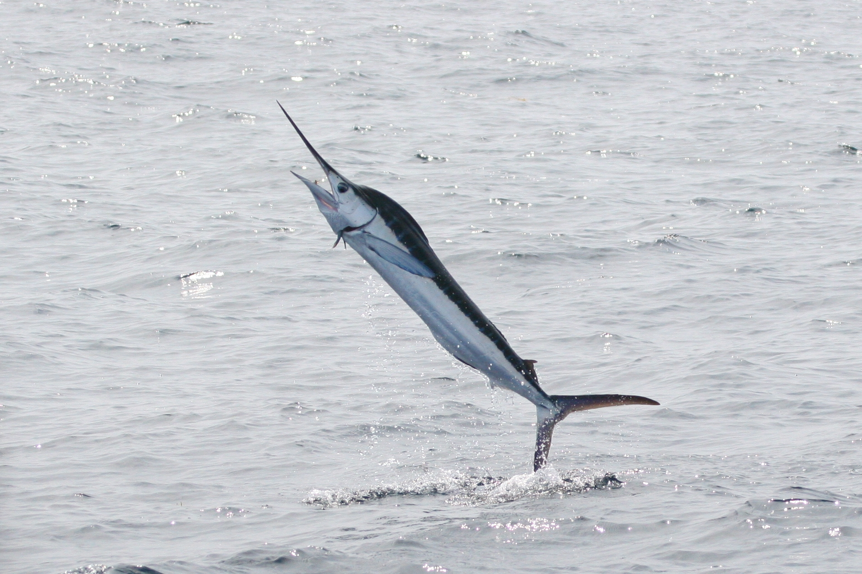

Dear Adult Marlin

Welcome back to a brand new year and a brand new class at Rye Primary! We hope you all had a wonderful holiday and that your children are as excited about their new learning as we are. I am thoroughly looking forward to the year ahead and I hope the children will be too. We have a very busy year planned with lots of fun and new experiences, whilst our expectations of your child’s effort and the work they will produce are very high.

Term 1 Learning in Marlin

‘Coast’

Our learning journey this term has a local interest at its heart. We will be studying the coastline from Pett Level to Camber Sands to consider how people have used the land and protected it from the sea. This will involve fieldtrips to gain first-hand experience of the locations (information to follow). From a scientific perspective, we will be studying the forces of water resistance and air resistance and their impact on the environment. The work of local artists, who have been inspired by this landscape, will be studied and their techniques used to inspire our own artwork.

English

The focus this term will be on story writing and explanation texts. The children will take inspiration from our fieldwork studies as well as our class novel ‘Floodland’ by Marcus Sedgwick.
How you can help your child
- Make sure your child reads daily at home and remembers to bring their book to school for our daily reading sessions. Don’t forget to record reading sessions in the new ‘Greedy Reader’ booklets.
- With the topic in mind, please find out and discuss as much information about the local coastline as possible.
- Discuss meanings of any new vocabulary they come across.
- Practise the spellings that are sent home weekly.

Mathematics

In Maths this term we will be focusing on developing our skills even further. We will develop our understanding of number systems, enjoy pattern sniffing, solve calculation problems and start to explore shapes.

How you can help your child
- Look for opportunities to talk about maths in the everyday environment.
- Support your child and give them time to use mental calculations skills in real life contexts.
- Help your child to learn his/her multiplication facts to become a Number Muncher.

PE

PE this term will be taught on Mondays. The focus will be on Invasion Games (Hockey). Please ensure your child has a named PE kit in school for the whole week as they may have a second PE session during the week.

Termly Homework Project

Using your developing knowledge of forces, design and make a model of a land yacht that could safely transport an apple across the playground.
(Be prepared for them to be tested!)
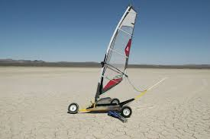

If you have any queries please do not hesitate to contact me.

Thank you for your continuing support.

Mr MacNicol

