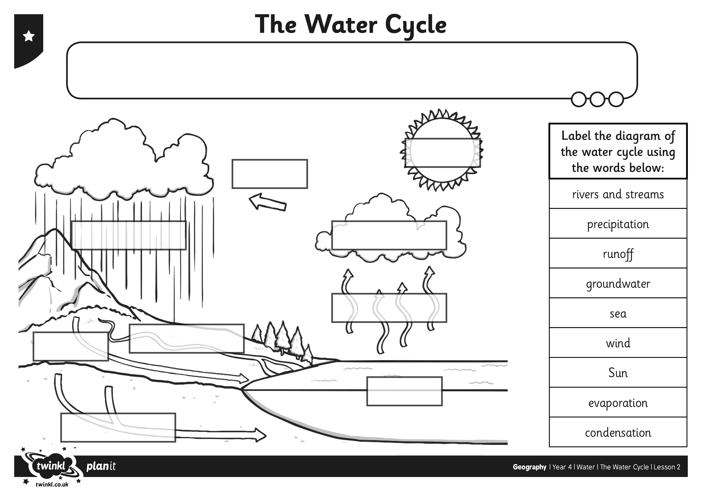

I can explain the key aspects of the water cycle.
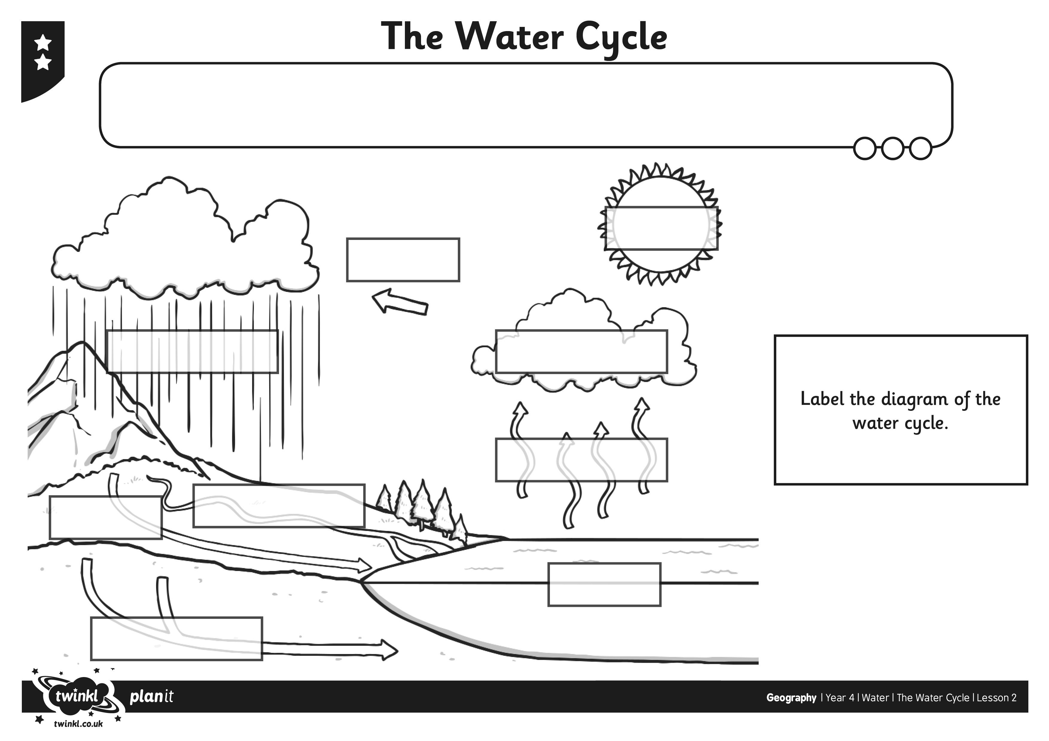
I can explain the key aspects of the water cycle.
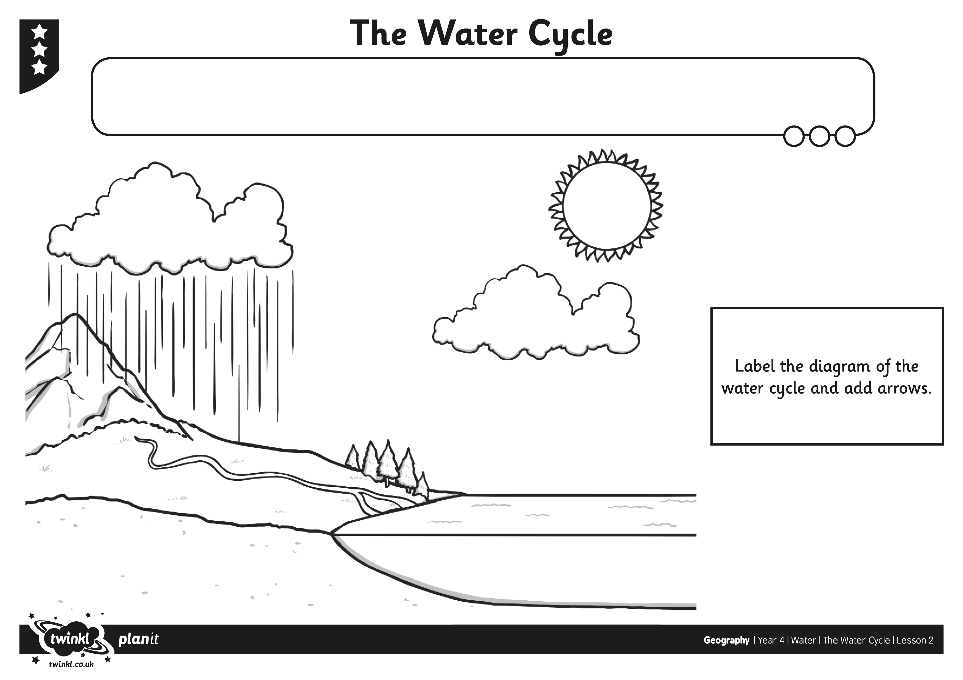
I can explain the key aspects of the water cycle.

