Can I create a PowerPoint template?

Open PowerPoint and select a new presentation.
Go to view and select slide master

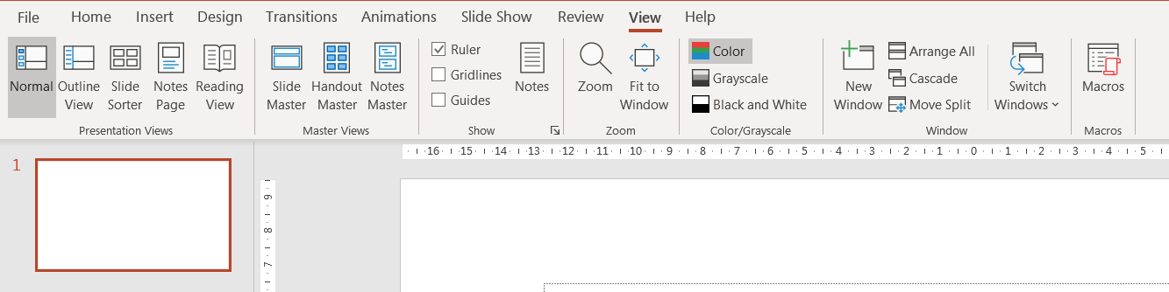

Click on slide number 1 at the top on the left hand side.
Then right click on the large slide in the centre of the screen.

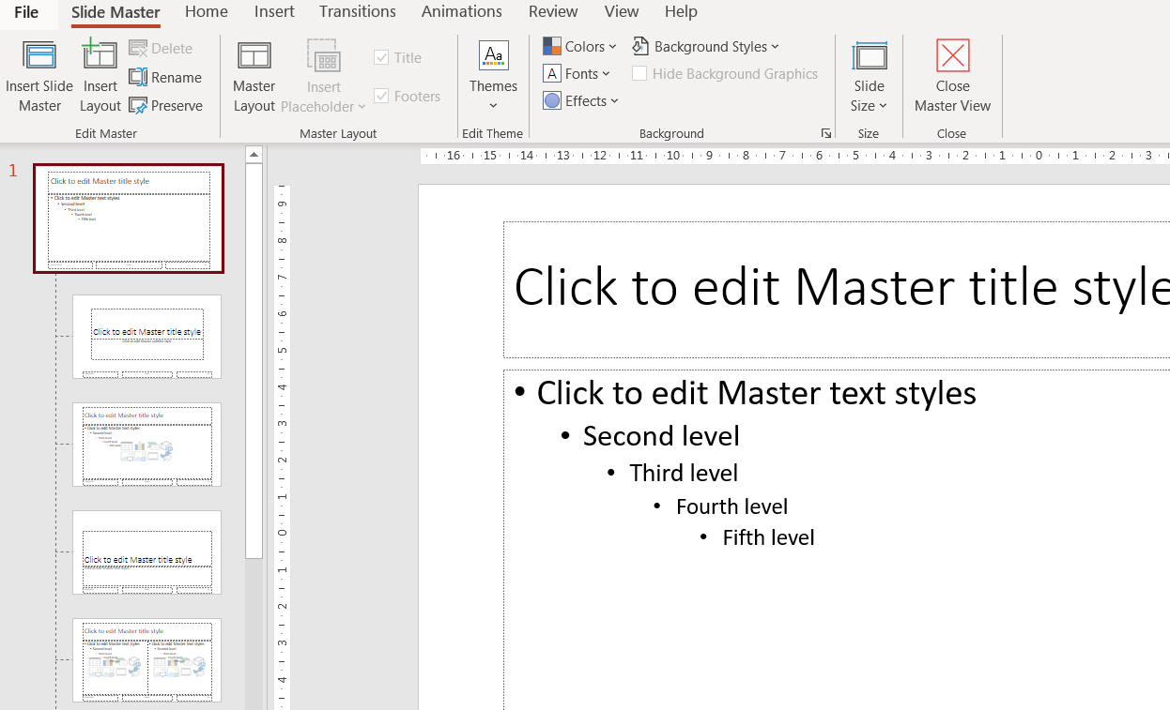

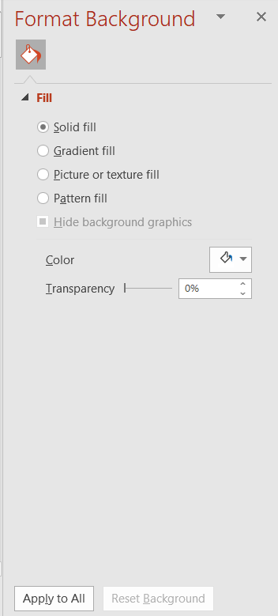
Choose format background.
You can choose a colour, texture or a picture. Play around with it and look at different options before you choose one. Tick the apply to all slides box.

When you are done click on the cross to close this window.
Then click on the edge of a text box and click on Home. You can now change the font (the letters) colour and size.
Don’t type anything.

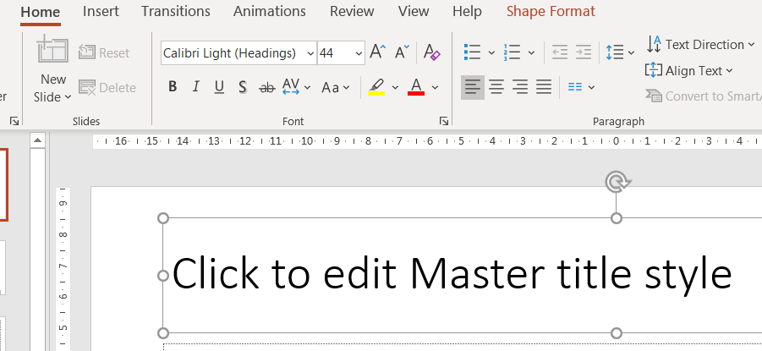

When you are done, click on slide master.

Select close Master View on the right.

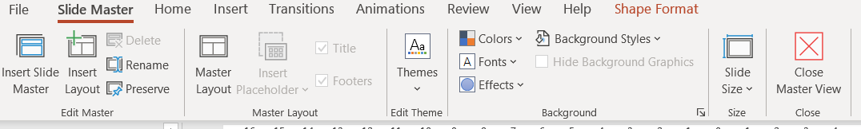

Save the file on the computer. We will continue to work on this next week.

