Can I create a PowerPoint presentation?

We would like you to create a presentation about the Romans. You can choose what you want to focus on. For example, Roman life
Each slide will be like a paragraph, so think carefully how you group the information. For example, if my presentation is about Roman life, I can have a slide about food and drink and another about Roman cities. If your PowerPoint is about Roman Emperors, you can have a slide for each ruler.

This week we want you to think about the titles for each slide and put these on your presentation
- Open PowerPoint
- Open the file with the template you created last week.
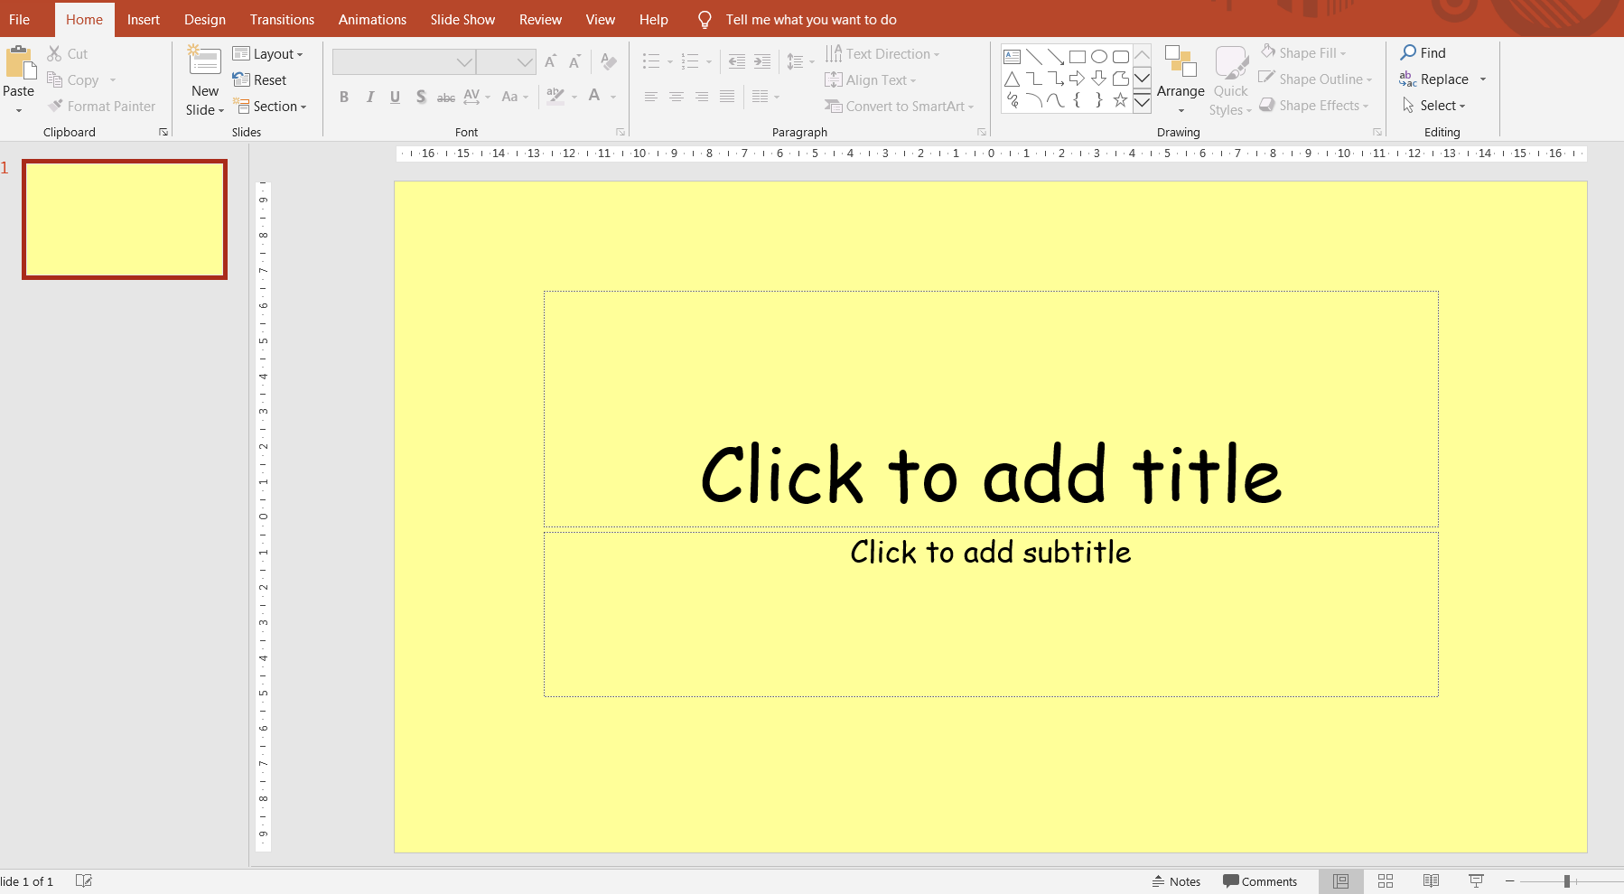
The first slide you see when you open your presentation is a title slide. You can type what your whole presentation is about on here.

Next, you need to add a slide by clicking on New Slide at the top. You should see some options as in the picture. Decide which one you want. Don’t worry – you can always change the lay-out later.
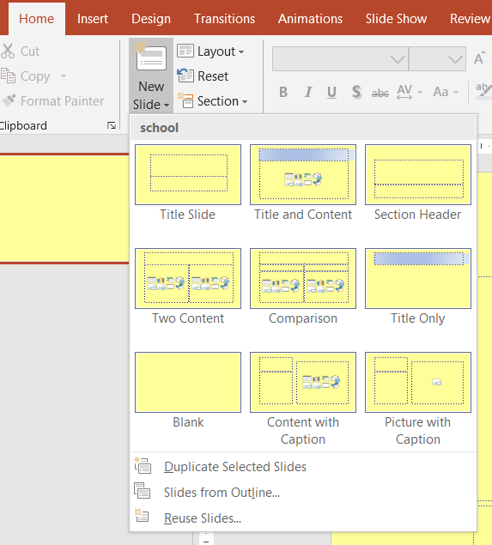

Do this until you have all the slide titles you think you may need.
Save the presentation and do some research ready for next week.

