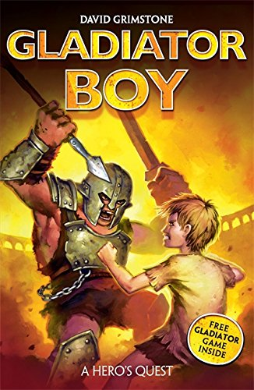
Gladiator Boy – Week 2
Day 1: Use inverted commas to indicate direct speech
- Think about the two characters in the model text, Decimus and Gladius.
- What might they say to each other? (use the speech bubbles to help if you prefer).
- Have a conversation about their feelings and the trial of endurance they will face.
- Maybe you could act this out with a grown up or older sibling.
- Jot down your ideas (you could draw them and add speech bubbles if you prefer).
- Think about how this conversation may be written.
- How could we extend the sentence with additional information?

Your Task
Write this conversation between Gladius and Decimus.
Remember to:
  - put inverted commas around spoken words.
  - use a capital letter at start of speech.
  - use speech punctuation inside inverted commas.
  - use a new line for each new speaker.
  - use a speech verb and adverb.
  - include additional information for the reader.

Day 2 Use a range of sentence openers.
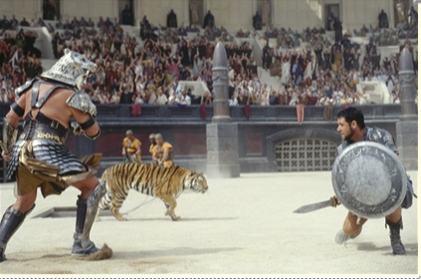
Look at the picture stimulus and discuss what is happening (move beyond what is seen and think about sounds and emotions).

Read:
Roaring crowds filled the arena, the noise was deafening but the atmosphere was electric. The gladiators wanted to win - they were desperate to survive. Courageously, they faced their opponent, they would not be intimidated. Moving forward, one brave gladiator surged forward, thrusting his sword at his enemy. Suddenly, out from beneath the stadium, a fierce, wild tiger pounced. Licking his lips, and roaring loudly, the tiger was ready to attack.

Look at the different types of sentence openers.
-ly adverb
Cautiously, they tiptoed through the dark tunnels.
Bravely, the hungry slaves started running.
-ing verb
Thrusting his sword forward, the slave practised with his new weapon.
Slamming the cells doors, the jailer locked the slaves up for the night.
-ed verb
Stunned, the slaves fell silent.
Amazed by the roaring crowd, they instantly wanted to win.

It is important to use a range of sentence starts in our writing to make it interesting for the reader, to keep the writing pacey, to add information. (If we started with ‘the’, ‘it’ the writing would be really boring!)

- Now write some sentence about the picture. Include an ly, ing and ed sentence opener.

Your task:
Your task is to write a descriptive paragraph based on the picture. Include a range of sentence types within your writing.
Remember to:
Include sentences that start with ly adverbs, ing verbs, ed verbs
Use past tense
Write in third person (he, they, she)

Day 3 Identify the features of a text.
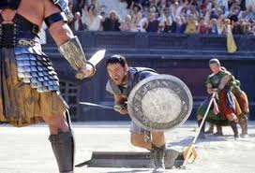

Write three sentences about the picture. Include an ly, ing and ed sentence opener.

Read:
“Now, let’s get you all moving!” growled the toothless jailer, unlocking the cell doors. Cautiously, sixty-four slaves entered the vast arena. As the hot sand of the arena floor burnt through the soles of their sandals, the slaves waited.

What (grammar) features of writing can be found in this paragraph?
What makes this great? Find examples of different features and write them into your book.
What different features did you find?

Did you find:
- Adverbials
- Fronted adverbials (where, when, how something happens)
- Speech(“Now, let’s get you all moving,” )
- Range of punctuation (. , ! - …… “ “ : )
Your task is to:
Read the following paragraph, what features can you find? Write down the examples.
A short distance away, three Trial Masters jumped down from the lowest row of stalls and began to march across the sand towards them. They were all very different in appearance: one was short and immensely fat, one was tall and practically stick thin, and the other was considerably older than his companions and covered in a network of scars.

Explain why you think some features occur more frequently.
Day 4 Organise paragraphs around a theme.

Re-read the model text.
Today you will be writing your own version of this action story opening.
Consider how it is structured.
- What is each paragraph about?
- How is it structured?
- What changes could you suggest for each paragraph to make the text your own?

Use the ‘Box Up Grid’ to help you make changes and plan your own action story opening.

Your task is to write up your own action story opening using the ideas you have written in the box up grid to help you.
Remember to include:
- Paragraphs with a different theme
- Adverbials (cautiously)
- Fronted adverbials (A short distance away)
- Speech(“Now, let’s get you all moving,” )
- Range of punctuation (. , ! - …… “ “ : )

I can’t wait to read your action story openings!

