Rye Writers Task

A few weeks ago, Noah submitted an idea for a Rye Writers task. Here it is:
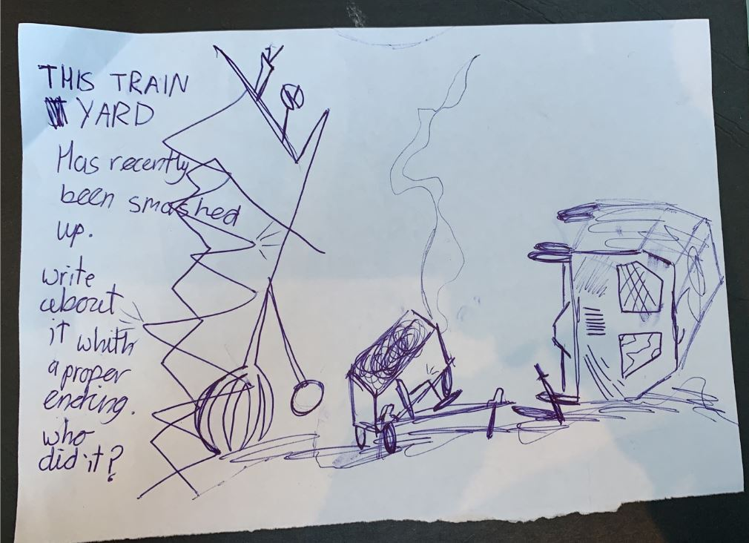
When you have completed Noah’s task, you can draw a picture of your own 'plot' idea, or just write a simple sentence, or even write a paragraph outlining the plot.
I will choose one idea for a different weekly task.

