Film name_____________________________ Name (age): _____________________ Date:________

Plot point _____ Super Sentence Stackers Today’s Super Three are:
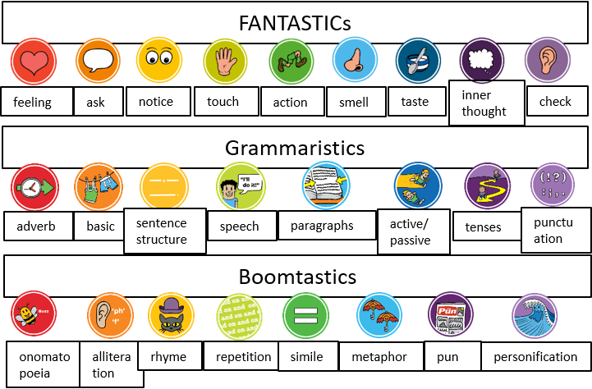
Today’s challenge: 3 for me to include

Story plot writing  ____________________________________________________  ____________________________________________________  ____________________________________________________  ____________________________________________________  ____________________________________________________  ____________________________________________________  ____________________________________________________  ____________________________________________________  ____________________________________________________  ____________________________________________________  ____________________________________________________  ____________________________________________________  ____________________________________________________  ____________________________________________________  ____________________________________________________  ____________________________________________________  ____________________________________________________  If you need more space, use a separate piece of paper. Take a clear photo of your work and send it in on Class Dojo. | 