English w/c 13 July

Based on The Sound Collector by Roger McGough.
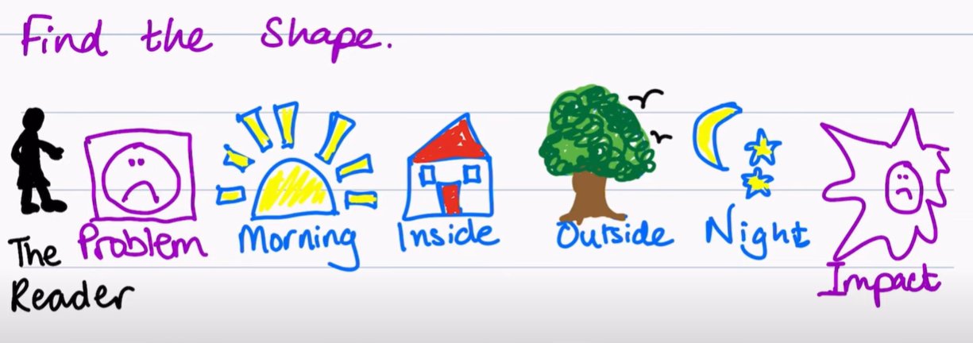

Monday – Lesson 5
Using the poem ‘The Sound Collector’ as a model, rewrite the third verse using colours with the lens of noticing (looking) and the lens of rhyme from the writing rainbow.
You need to focus on outside colours.

Example: orange of the butterfly. Butterfly could rhyme with high, try, sky. There are lots of colours in the sky. I am going to choose…

Tuesday – Lesson 6
Using the poem as a model, rewrite the fourth verse using colours with the lens of noticing (looking) and the lens of rhyme from the writing rainbow.
You need to focus on night colours.

Example: Brown of the night owl. Owl rhymes with towel, prowl, growl.
Example: Black of the shadows. Shadows rhymes with meadows, nose, froze.
Example: Silver of the moon. Hmm, I used the colour silver last week. Do I want to use it for an outside colour or an inside colour. If I want to use it for an night time colour, I need to change my inside verse from last week.

Wednesday – Lesson 7
Finish your poem. Use the lens of rhyme.

A stranger came this morning
He didn’t leave his name
He left us …….

Edit the poem. Are there any colours you wished you had used?
Any colours that would have been better for inside or outside? Morning or night?
Any colours you used twice? You should only use a colour once.
Make improvements, then write up a neat version of your final poem and illustrate it.

Thursday – Lesson 8
Go to https://www.bbc.co.uk/teach/school-radio/english-ks2-roger-mcgough-talking-poetry/zmqf2sg Scroll down until you find the poem The colour collector. Compare your poem to Roger’s. Which one do you like best? Have you written similar things? Used the same or different colours?
Can you create a Venn Diagram to show how your poem is different and the same?

