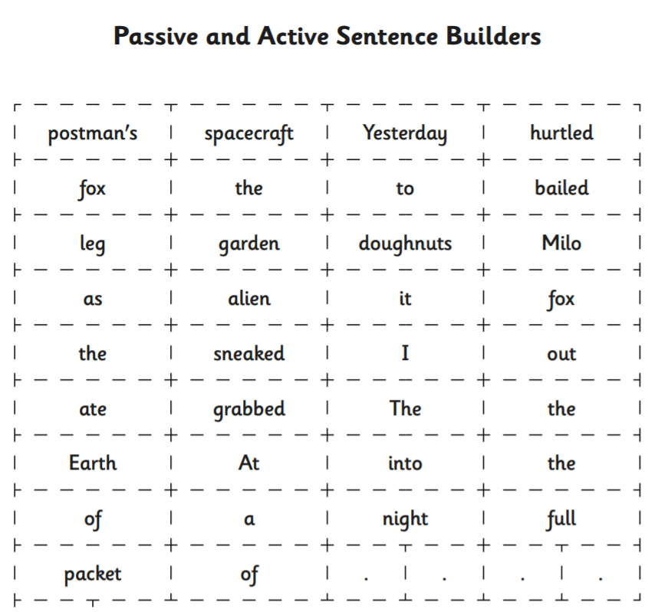

Sort into four different sentences, either into your books or on your whiteboard.

