What do you think it  was used for? | What do you think is happening in the photograph? | Whom might it have belonged to?
What do you think it  was used for? | 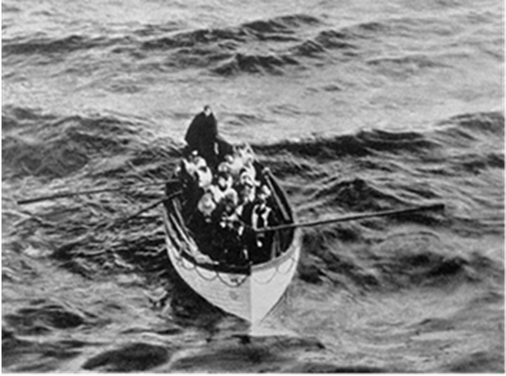 | Whom might it have belonged to?
What does it tell us about the sinking of the Titanic? |  | Why do you think this photograph was taken?
What does it tell us about the sinking of the Titanic? | What would you like to know about it? | Why do you think this photograph was taken?

Source A - What does this source tell you about the Titanic disaster?

Source B - What does this source tell you about the Titanic disaster?
What do you think it  was used for? | What do you think is happening in these photographs? | Whom might it have belonged to?
What do you think it  was used for? | 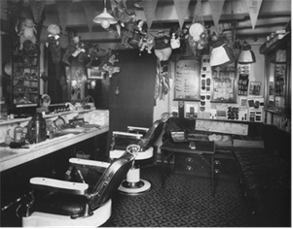  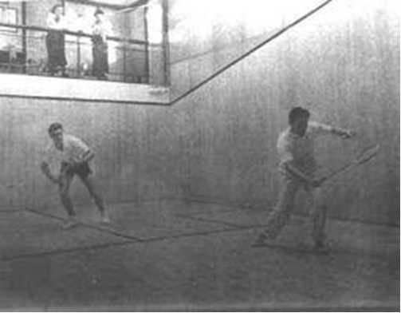 | Whom might it have belonged to?
What does it tell us about life on the Titanic? |  | Why do you think this photograph was taken?
What does it tell us about life on the Titanic? | What else would you like to know about the photograph? | Why do you think this photograph was taken?

Source C - What does this source tell you about the Titanic disaster?
What does it tell us about the Titanic disaster? | What do you think it was used for? | Whom might it have been written for?
What does it tell us about the Titanic disaster? | 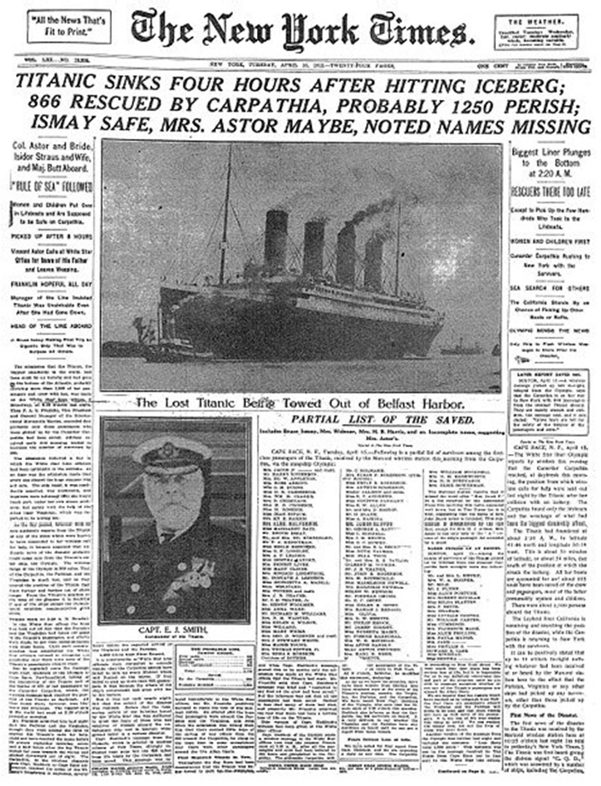 | Whom might it have been written for?
What does it tell us about the Titanic disaster? |  | Why do you think this source is important?

Source D - What does this source tell you about the Titanic disaster?
Whose point of view does the image show? | What do you think is happening in this image? | Whom might it have belonged to?
Whose point of view does the image show? | 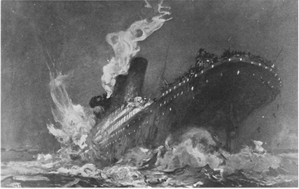 | Whom might it have belonged to?
What does it tell us about the sinking of the Titanic? |  | Why do you think this image was created?
What does it tell us about the sinking of the Titanic? | What else would you like to know about this image? | Why do you think this image was created?

