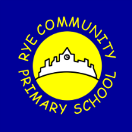
Rye Community Primary School
“A Gateway to learning”

Parental Medicine Consent Form

To be completed by the parent/guardian of any child to whom drugs may be administered under the supervision of school staff

Please complete in block letters

Name of Child: ………………………………………………………..Date of Birth:

Address

Medical Diagnosis/Condition/illness:

Date: ……………………………...................Class/Form:

Review Date:

Doctor's Name: ……………………………….Doctor's telephone number:

The Doctor has prescribed (as follows) for my child:

a) Regularly:

Name of Drug or Medicine:

How often (e.g.; Lunchtime? after food):

How much (e.g.; half a teaspoon? 1 tablet?) to be given:

b) In special circumstances: (here describe what circumstances, and the nature and dosage of the prescribed medication or treatment)

A separate form must be completed for each medicine.

I accept that I must deliver the medicine personally to (agreed member of staff). The above information is, to the best of my knowledge, accurate at the time of writing and I give consent to the school/early year’s setting staff administering medicine in accordance with their policy. I will inform the school/setting immediately, in writing, if there is any change in dosage or frequency of the medication or if the medicine is stopped.

I understand that it may be necessary for this treatment to be carried out during educational visits and other out of school activities, as well as on the school premises.

I undertake to supply the school with the drugs and medicines in properly labelled containers.

I accept that whilst my child is in the care of the School, the School staff stand in the position of the parent and that the school staff may therefore need to arrange any medical aid considered necessary in an emergency, but I will be told of any such action as soon as possible.

Signed: ……………………………………….

Date: …………………………………………

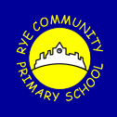
Record of Medicine Administered to Pupils – Primary School

Name of pupil: Class: Date Commenced: Date Completed

Date | Name of medicine | Consent form checked: child/meds | Dose Given | Time | Any reactions | Refused | Signature of staff | Print name

Record of Medicine Administered to Pupils – Pugwash Nursery

Name of child: Date Commenced: Date Completed

Date | Name of medicine | Consent form checked: child/meds | Dose Given | Time | Any reactions | Refused | Signature of staff & Witness | Print names | Parent signature

Record of Asthma Medication Administered to Pupils - Asthma

Name of pupil: Class: Date Commenced: Date Completed

Date | Name of medicine | Consent form checked: child/meds | Dose Given | Time | Any reactions | Refused | Signature of staff | Print name

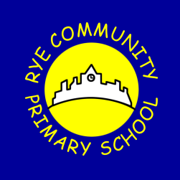
Individual Healthcare Plan

Name of school/setting | Rye Community Primary School
Child’s name
Group/class/form
Date of birth
Child’s address
Medical diagnosis or condition
Date
Review date
Family Contact Information
Name
Relationship to child
Phone no. (work)
(home)
(mobile)
Name
Relationship to child
Phone no. (work)
(home)
(mobile)
Clinic/Hospital Contact
Name
Phone no.
G.P.
Name
Phone no.

Who is responsible for providing support in school

Describe medical needs and give details of child’s symptoms, triggers, signs, treatments, facilities, equipment or devices, environmental issues etc

Name of medication, dose, method of administration, when to be taken, side effects, contra-indications, administered by/self-administered with/without supervision

Daily care requirements

Specific support for the pupil’s educational, social and emotional needs

Arrangements for school visits/trips etc

Other information

Describe what constitutes an emergency, and the action to take if this occurs

Who is responsible in an emergency (state if different for off-site activities)

Plan developed with

Staff training needed/undertaken – who, what, when

Form copied to

Parent/Carer signature

