Try and work out if you need to add or subtract to solve these word problems.
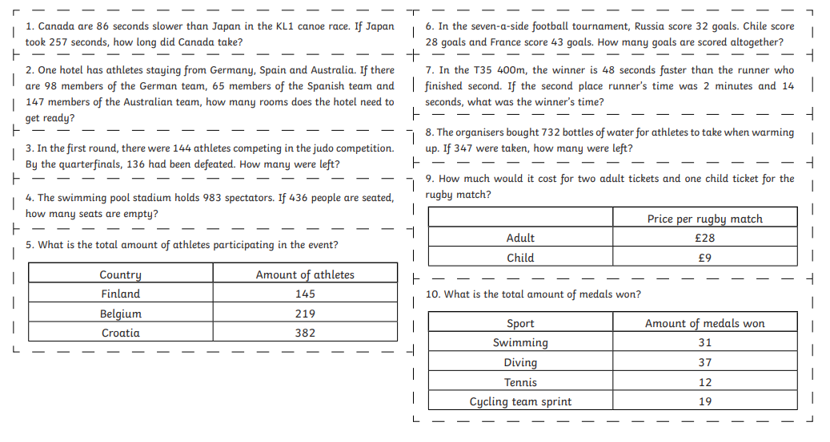
The complete your calculations and show your workings.

