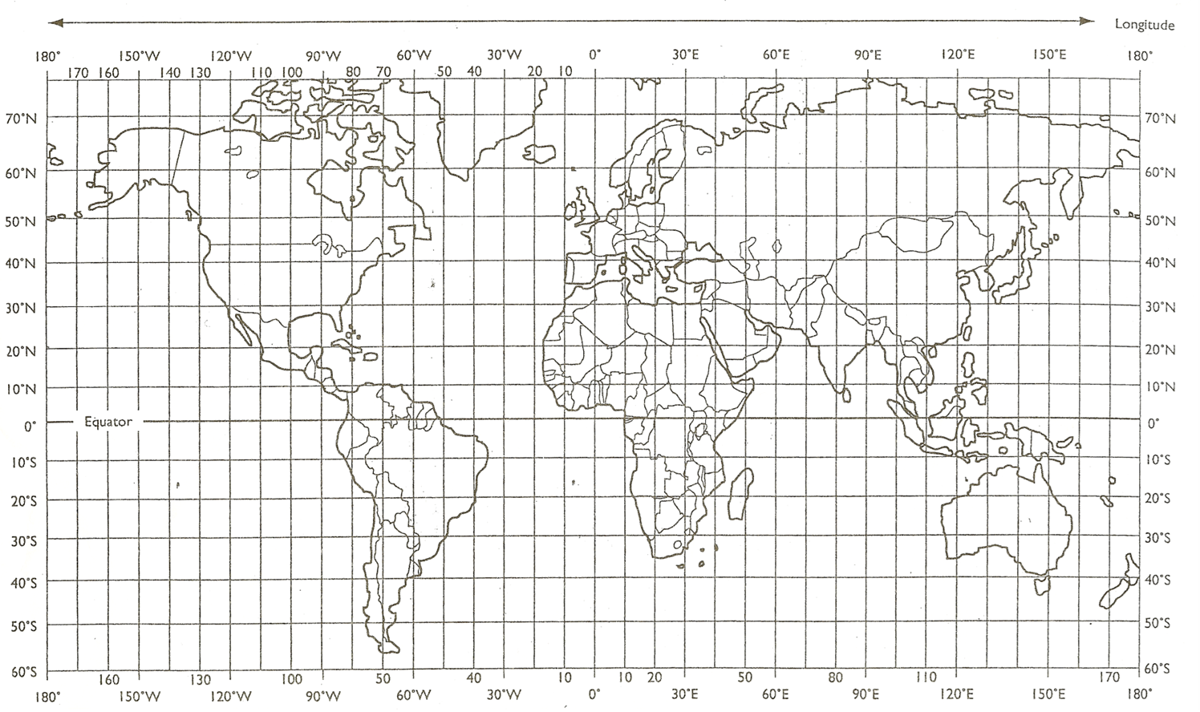

20° N 110° W - Mexico

40° S 50° W - Argentina

35° N 10° W - Portugal

60° N 90 ° E - Russia

50° N 0° - United Kingdom

15° S 20° E - Angola

35° N 40° E - Turkey

50° N 110° W – United States of America

20° N 80° E - India

45° S 170° E – New Zealand